SIMILAR SHAPES (LENGTH)
Pearson Edexcel - Tuesday 21 May 2019 - Paper 1 (Non-Calculator) Foundation Tier

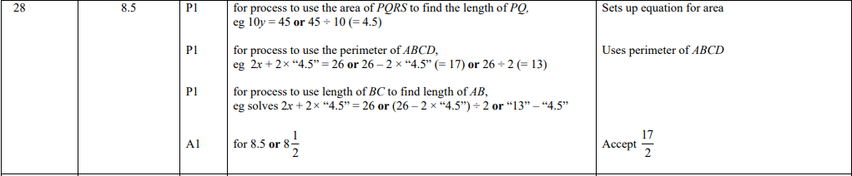

Pearson Edexcel - Tuesday 6 November 2018 - Paper 1 (Non-Calculator) Foundation Tier

Pearson Edexcel - Tuesday 12 June 2018 - Paper 3 (Calculator) Foundation Tier

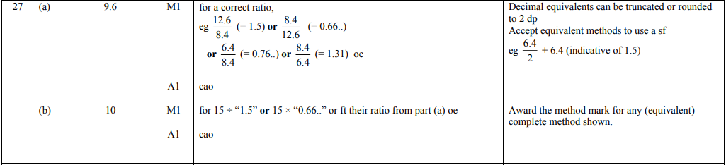

Pearson Edexcel – Specimen 2 - Paper 2 (Calculator) Foundation Tier

OCR Tuesday 11 June 2019 – Morning (Calculator) Foundation Tier
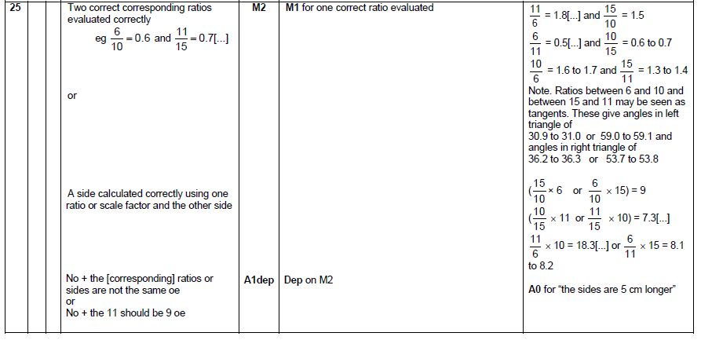

OCR Thursday 7 June 2018 – Morning (Non Calculator) Foundation Tier
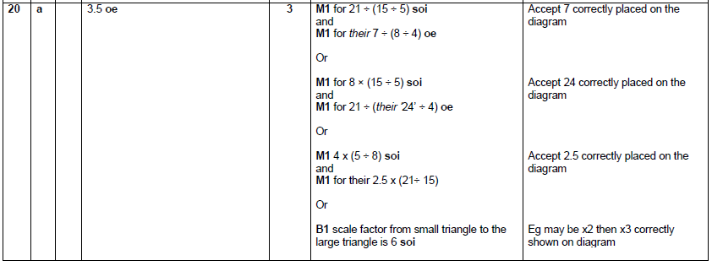

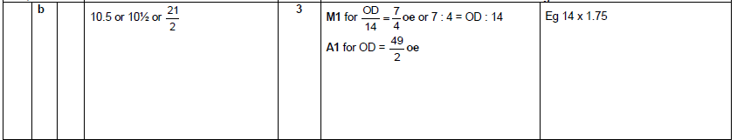

OCR Sample Question Paper 3 – Morning/Afternoon (Calculator) Foundation Tier

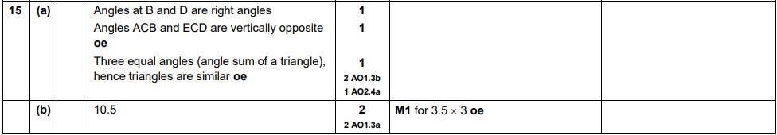
AQA Monday 8 June 2020 – Morning (Calculator) Foundation Tier

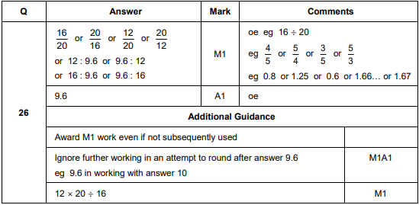
AQA Thursday 24 May 2018 – Morning (Non-Calculator) Foundation Tier

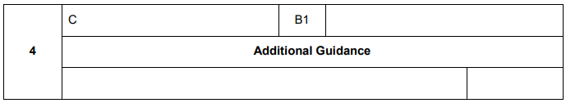

AQA Tuesday 12 June 2018 – Morning (Calculator) Foundation Tier

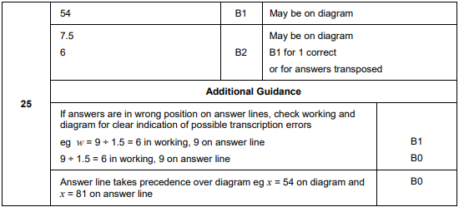
AQA Tuesday 13 June 2017 Morning– Morning (Calculator) Foundation Tier

